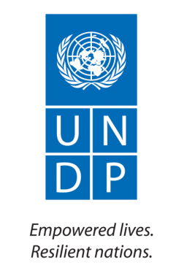
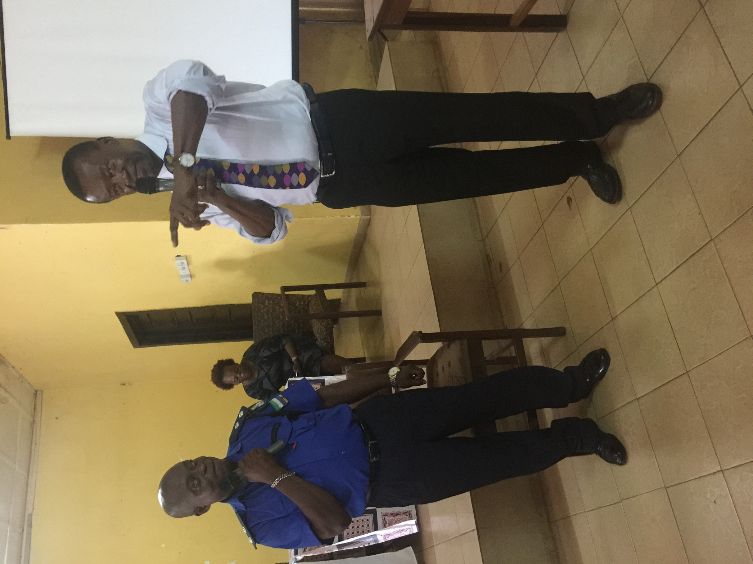

United Nations Development Programme
Sierra Leone
Rule of Law Programme
Award ID 00090095
Annual Progress Report
2017
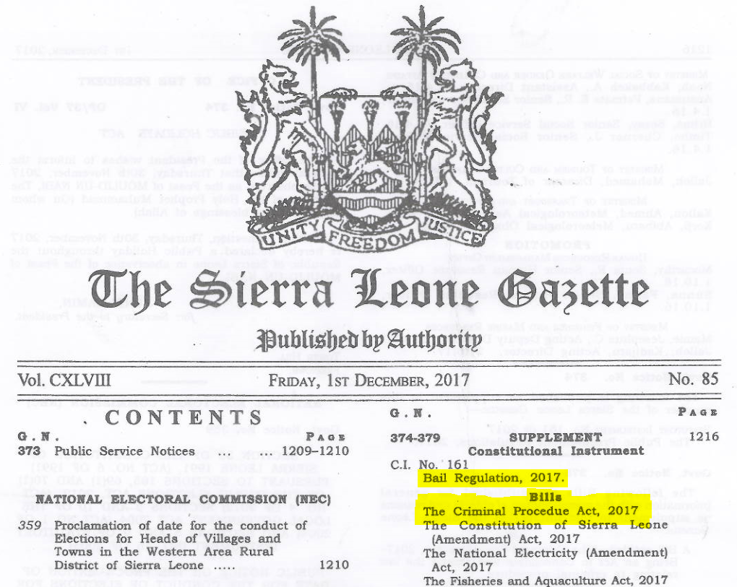

Acronyms

UNDP – United Nations Development Programme
CMS – Case Management System
CSO – Civil Society Organization
GoSL – Government of Sierra Leone
HC – High Court
HRBA – Human Rights-Based Approach
HRC – Human Right Commission
IP – Implementing Partner
IPCB – Independent Police Complaints Board
INL – International Narcotics and Law Enforcement Affairs
JSCO – Justice Sector Coordination Office
Justice App – Justice Application
LAB – Legal Aid Board
LOD – Law Officers’ Department
MC – Magistrates Court
MIA – Ministry of Internal Affairs
MOJ – Ministry of Justice
M&E – Monitoring and Evaluation
ONS – Office of National Security
SGBV – Sexual and Gender-Based Violence
SL – Sierra Leone
SLCS – Sierra Leone Correctional Service

Table of Contents

I. Project Status Information 4
II. Executive Summary 6
III. Indicators Based Performance Assessment 8
IV. Results 9
V. RISKS AND ISSUES 11
VI. Partnerships 14
VII. Innovative Initiatives 14
VIII. Challenges Lessons learned and Recommendations 14
IX. Financial report 2016 16
X. Monitoring and Evaluation 19
XI. Annexes 20

Project Status Information

Project title | Rule of Law Programme
Project ID | 00096027 – Promoting Transparency in Sierra Leone’s Judiciary  00102631 – From Prisons to Corrections  00104225 – Strengthening RoL, Security and Human Rights in Sierra Leone  XXXXX – Human Rights Commission
Project start Date / end Date | XXX -  00096027 – 1 January 2015 – 31 December 2017  00102631 – 1 October 2016 – 31 December 2018  00104225 – 1 January 2017 – 31 December 2019
Implementing Modality | DIM  NIM – Human Rights Commission
Implementing Partner(s) | MIA, MOJ, Judiciary, SLCS, SLP, IPCB, JSCO, LAB, HRC, CSOs
Cluster name | Governance Cluster
Donors | UNDP TRAC and Bureau of International Narcotics and Law Enforcement Affairs (INL) US State Department

Project Objective | Enhancing the ability of rule of law and security institutions to deliver services in a transparent and accountable manner to the most vulnerable and marginalized groups in SL
UNDP RPD outcome / UNDP Strategic Plan RRF outcome | 2014-2017 Countries have strengthened institutions to progressively deliver universal access to basic services  2018 – 2021 (2) Strengthen effective, inclusive and accountable governance and (6) strengthen gender equality and the empowerment of women and girls

Annual Budget  (US$) | Expenses as of 31 December 2017  (US$) | expenses  (% of annual budget)
RoL 665,000  INL Judiciary 776,904 (+ Unprogrammed?)  INL SLCS 848,466  HRC – 150,000 | Patrick and Mahmoud

Project Budget  (US$) | Total Project expenses  (US$) | Project Balance  (US$) | Total expenses  (% of total budget)
2,440,370

Executive Summary
This rule of law interventions seeks to strengthen rule of law, access to justice and security delivery in Sierra Leone in compliance with international human rights standards. It builds on the lessons learnt from UNDP’s Access to Justice and Security Sector Reform (SSR) projects and years of UN and development partners’ support to justice and security delivery. The project establishes shared priorities with an aim of contributing to the maintenance of peace and stability and to strengthen the rule of law, access to justice, accountability and transparency. The objective is to ensure equal access to justice for all, focusing on the most marginalized, those vulnerable in the justice sector particularly women. The project is aimed at addressing gaps in the justice sector chain and correctional services and to also build on achievements under the two thematic projects “Promoting Transparency in Sierra Leone’s Judiciary” and “From Prisons to Corrections: Promoting Institutional Reforms of the Sierra Leone Correctional Service” that are supporting and strengthening legislative and institutional reforms.
Three (3) key outputs underpin the development and implementation of the rule of law programming namely:
- Justice and security sector coordination and data management enhanced for inclusive, accountable and evidence-based policy and law making;
- Improved access to justice for rights holders especially for women and vulnerable groups;
- Strengthened justice and security sector institutions to deliver effective justice and security services closer to the people and in compliance with human rights standards.

Within the first year of implementation in 2017, the project has aimed at establishing much needed perceptions in the sector to ensure to guide justice and security sector interventions. Furthermore, the project has strived to strengthen partners’ M&E capacities which are significant in ensuring implementing partners (IPs) are able to generate, analyze and disseminate data on their work to inform their own programming as well as disseminating information on progress made within their institutions in addressing systemic service delivery issues. To ensure the vulnerable and marginalized especially women and girls are catered for, the project supported the Legal Aid Board (LAB) to provide legal assistance and representation for women in civil cases around property and inheritance, divorce and land rights in 402 cases with 104 successfully litigated and concluded. Advisory services have been provided in additional 189 cases. Review of the LAB Training Paralegal manual has been initiated and the institution has been supported to commence the mapping of all legal aid service providers nationwide. These two interventions when concluded in 2018 will place the LAB in a strategic position to engage with other legal aid service providers as well as conduct training of paralegals using a standardized curricular.
Under the thematic project – Promoting Transparency in Sierra Leone’s Judiciary aimed at enhancing transparency in judicial processes, the new Bail Regulations were finalized in June 2017 and finally passed in Parliament through a Constitutional Instrument in December 2017. The Sentencing Regulations were finalized and awaits the approval of the revised Criminal Procedure Act which received Cabinet approval already in December 2016. The first ever electronic criminal case management system has been developed as a mobile application, - Justice App allowing the Chief Justice and senior management to monitor case progress in a speedy and efficient manner. The system is low-cost and utilizes user-friendly software and can be used offline.
To enhance access to justice for the most vulnerable, UNDP supported a civil society organization who provided assistance in 76 cases of sexual and domestic violence (44 sexual penetration; 30 domestic violence and 2 rape cases). Out of 52 matters charged to court, 11 have been completed with successful convictions. Under the From Prisons to Corrections project, the Saturday Prison Pilot Courts reviewed more than 1000 cases, and has ensured that more than half of the 802 inmates without indictments have since been served and the trials have now commenced before the High Courts.
The Sierra Leone Correctional Services (SLCS) have equally under the From Prisons to Corrections project embarked on the revision of the Correctional Legal Framework which has received the support of the Minister of Internal Affairs and Correctional Council as well as conducted pilot human rights audits and trained the 19 Facility Managers on the UN Standard Minimum Rules for the Treatment of Prisoners (Mandela Rules) and the United Nations Rules for the Treatment of Women Prisoners and Non-custodial Measures for Women Offenders (Bangkok Rules) . This led to the development of a Human Rights Action Nationwide Plan that is gradually being implemented by the SLCS. UNDP supported the SLCS in the development of a Accommodation Master Plan and Industries Masterplan that will support government and the institution in identifying and implementing immediate, short-term and long-term priorities to ensure sustainable reforms.
The Human Rights Commission (HRC) in an innovative approach initiated the process of mobile clinics which have been instrumental in bringing justice closer to the people allowing them to lodge complaints to the Commission during field visits.
While much progress has been made with the implementation of the project, many challenges and risks remain:
- Decline in donor funding / support to the country while government still has not yet prioritized the justice and security sectors partially also due to the availability of the resources;
- Implementing Partners non-compliance with UNDP reporting requirements causing delays in report closure and also affecting delivery and progress against targets;
- Fiduciary risk of partners handling funds remains a concern with some institutions having weak internal administrative systems in place.

Indicators Based Performance Assessment

Indicators | Baseline | Target | Achieved Target (current Status) | Reasons for Variance | Source of Verification
Project Results:
Output 1 : Justice and Security Sector Coordination and data management enhanced for inclusive, accountable and evidence-based policy and law making
# justice and security sector coordination meetings held | Limited coordination in the sector and Sector Actors do not meet regularly to discuss policy initiatives in the criminal justice sector | 6 justice and security sector coordination meetings conducted by the JSCO | 6 coordination meetings held by the JSCO with over 30 participants from justice and security sectors |  | JSCO Report on 2017 LOA
# and type of CMS established and functional within justice and security sector partners | No CMS in place for the MOJ and sector institutions | 1 Justice App developed for the Judiciary and 1 CMS established for the MOJ | 1 Justice App developed and functional within the Judiciary with 4 Magistrate Courts (MCs) and 3 High Courts (HCs) |  | Report from LOA with Judiciary
# and type of M&E capacity strengthening initiatives conducted with data management of IPs structures enhanced | Limited capacity of LOD and sector institutions to collect and analyze data for policy development | 4 M&E capacity building sessions held with modules developed to enhance partners knowledge on data collection, analysis and dissemination and integrating HRBAs | 2 modules developed by the JSCO and 4 training sessions held with 30 representatives from justice and security sector |  | JSCO LOA Reports
# perception survey within the justice and security sector conducted to measure people’s perceptions in sectors | Limited available information on people’s perception in the sector | 1 perception survey conducted in the sector | 1 perception survey conducted by the JSCO on justice and security sector service delivery |  | Report of 2017 Perception Survey
Output 2 : Enhanced access to justice and security for rights holders’ incl. women and vulnerable groups
# women and girls accessing legal aid services | Limited # of individuals especially women having access to legal aid | 250 women have access to legal aid services in civil and criminal cases | 120 LAB paralegal skills enhanced and legal aid support provided to 402 cases involving women and girls on inheritance, land and property with 104 cases concluded |  | ROL DEX Q4 Report and LAB Data for 2017 implementation
# Legal aid service providers mapping undertaken | No Legal aid service providers mapping conducted; | 1 legal aid service providers mapping exercise conducted | 1 legal aid service providers mapping initiated by the LAB and to be concluded in 2018 |  | See Preliminary report of mapping exercise
# CSOs supported; # SGBV cases investigated and medically treated | In 2016, only 2 CSOs supported;  270 sexual and domestic violence cases investigated with 203 receiving medical attention and shelter services | 2 CSOs supported with 100 SGBV cases investigated and supported; | 1 CSO supported in 2017 with 81 cases received and investigated with 33 sheltered; 102 victims and witnesses assisted to attend more than 6 court sittings; |  | Final MCG Report from IP and ROL DEX Report for Q4
# Cases charged to courts and # convictions secured | 186 cases charged to courts with 27 convictions | 30 convictions secured | 53 charged to court and 16 convictions secured | Limited funding resulted in supporting only 1 IP/CSO | Final MCG Report from IP and ROL DEX Report for Q4
Output 3 : Strengthened justice and security sector institutions to deliver effective services closer to the people and in compliance with human rights standards.
# IPCB staff benefitting from investigative capacity strengthening initiatives | Limited investigative capacity of the IPCB | IPCB staff from the investigative unit have skills enhanced | 2 professional investigators have been recruited by the IPCB to further strengthen the investigative ability of that Unit. The planned capacity building (South-South to Kenya and South Africa) was cancelled due to the political environment in Kenya in 2017 |  | Report from LOA with IPCB and ROL DEX Q4, 2017
# job fairs to attract female applicants in the SLP conducted | 2 awareness sessions held by SLP in 2016 to encourage recruitment of female officers within SLP | 2 job fairs held by SLP Gender Directorate to encourage the enlistment of female applicants in the SLP | The SLP Gender Unit held job fairs across 3 regions of North, South and East bringing together 2,473 females and 1,370males to raise awareness and shift the negative thinking on the enlistment of females in the police force |  | ROL DEX Report for Q4 2017
A case management system established for the MOJ-Yes/No | No CMS for the MOJ and limited data management capacities | 1 CMS developed and established for the MOJ to aid administrative functions and data collection | Needs assessment have been undertaken for the development of the CMS for the MOJ. Process flows have also been developed and the CMS for the MOJ will be finalized in 2018 | Delays in recruitment of consultancy firm resulted in further delays in completing work by consultant in 2017 | Progress Report Consultant-IDTLABS
# of Joint town hall meetings held by IPCB/CSOs on critical policing issues in the South and East Regions | Limited formal engagement between justice/security sector institutions and CSOs at community levels | 3 joint IPCB/CSOs Town Hall meetings held on key policing issues | The IPCB with support from CSOs successfully organized 3 joint workshops on policing in Bo, Kenema and Makeni with over 300 participants in attendance with wider knowledge built on policing and maintaining human right standards |  | IPCB LOA Report and ROL DEX Q4, 2017
Output 4 Effective Project Management

Results

Section 1: Overall results achieved against the outcome

Section 2: Results achieved against Outputs

Output1:

Narrative section: state the results achieved toward the output

Activity Result 1.1: activity result activity result activity result

Activity Result 1.2: activity result activity result activity result

Output 2:

Narrative section: state the results achieved toward the output

Activity Result 2.1: activity result activity result activity result

Activity Result 2.2: activity result activity result activity result

RISKS AND ISSUES
Project Risk and Issue Log
# | Description and Date Identified | Type | Probability and Impact | Countermeasures / Management response | Status
Risks
1 | Description: Program set up and implementation takes longer and affects delivery for the entire year  Date Identified: 20 December 2016 | Operational | Delays in project implementation and in the achievement of results  3  Probability (very likely=5, Likely=4, Moderate=3, unlikely=2, very unlikely=1)  Impact on results (critical=5, severe=4, moderate=3, minor=2, negligible=1) | Management has discussed and charted way forward to remedy to yearly challenges. As part of the solution, it is now anticipated that all annual work plans should be discussed with partners, prepared and completed by 15 December each year so that implementation can start in January of the next year. | Reducing
2 | Description: The build up to the electoral cycle in Sierra Leone has got the potential to adversely affect the smooth implementation of activities especially those to be implemented in the province  Date Identified: 12 June 2017 | Political | 4 | Management has discussed with programme colleagues and the way forward is to ensure that interventions to be carried out involving parliament and senior government officials shall be completed before 1 November 2017. In furtherance, activities in the provinces shall be fast tracked. The projects are encouraged to develop strong monitoring plans to track their work and work closely with partners to ensure smooth implementation.  For 2018, the AWPs are planned with due consideration to electoral activities. | Reducing
3. | Description: Full funding for the program is not available  Date Identified: 1 July 2015 | Financial | 4 | This is a recurring risk, and so far the Rule of Law Team has been active in fundraising both with donors present in Sierra Leone and also with donors not present. Also UNDP HQ and Regional Office has on a regular basis been informed of results, progress and new innovations that could potentially attract donors. INL has been a donor since 2015 and is presently supporting several outputs of the Rule of Law and additional funding has been sought from this donor and we are awaiting final response. | Ongoing

Partnerships
The establishment of multi-stakeholder partnerships is a strategic modus operandi throughout the implementation of the projects. The key implementing partners are the justice, security and human rights institutions with which the projects were formally devised and agreed. These include Sierra Leone Police, Ministry of Justice, Judiciary, Correctional Service, Independent Police Complaints Board, Human Rights Commission and Civil Society Organizations. These institutions have clear mandates and play a critical role to improve access to justice, maintain security and strengthen oversight and the human rights protection framework of the country. The partnerships have continued to grow throughout 2017 and while UNDP Rule of Law Team supports partners, these take the lead in identifying their needs and priorities and which areas need UNDP support.

Innovative Initiatives
A Justice App has been developed by UNDP and a national software company and launched in May 2017 by the Chief Justice providing the Judiciary with its first ever criminal electronic case management system for the criminal courts. It has been successfully piloted in 3 High Courts and 3 Magistrates Courts in Freetown and Makeni. The Justice App is presently being expanded to include 4 additional High Courts and 4 Magistrate Courts in Kenema, Bo and Freetown. The system is low-cost and utilizes user-friendly software and can be used offline, and once connected to the internet all case data uploads automatically to the Cloud. This allows for the Chief Justice and senior management to monitor case progress in a speedy and efficient manner.

Challenges Lessons learned and Recommendations
The projects have not had faced major challenges this year, except for continued funding constraints which has affected the full achievement of targets and activity results designed in the Rule of Law umbrella project. This has been mitigated by the Rule of Law Team by prioritizing with implementing partners the most crucial activities as well as lobbying donors for additional funding for the projects. Presently, the UNDP has submitted a full project proposal as per donor request.
Implementing partners are still submitting progress reports with delays, which has impacted implementation and delivery, as UNDP has not been able to disburse funds in line with the initial planned Annual Work Plans (AWPs) for some institutions. The project team will address this issue in early 2018 through consultation with senior management of the concerned institutions and also by providing further monitoring and training. The recruitment of a national Rule of Law Officer – with reporting, monitoring and evaluation skills will hence also be prioritized in the first quarter of 2018 as this was a vital recommendation, to improve reporting, monitoring and evaluation, of the earlier evaluations that also shaped the new project interventions.
Finally, the projects have faced some challenges in recruitment of required expertise, but this has been mitigated through re-advertisements of terms of reference and also sourcing expertise from the UNDP roster.

Financial report 2016
Table 1: Overview of available resources for the project duration

Donor | contribution | Expenses |  |  | Total expenses | Balance
 |  | Year 2014 | Year 2015 | Year 2016
UNDP
TOTAL

Table 2: financial summary (Based on Project Transaction details)

Project Output | Planned Activities  (Activity Results) | Budget | Total expenses | Commitments | Balance | % utilization
Atlas Activity 1:
Atlas Activity 2:
Atlas Activity 3:
Atlas Activity 4:
Total

Table 3: financial utilization by donor (Based on Project Transaction details)
This table is optional
DONOR 1 DONOR 1 DONOR 1
Project Output | Planned Activities  (Activity Results) | Expenditure
Atlas Activity 1:
Atlas Activity 2:
Atlas Activity 3:
Atlas Activity 4:
Total

DONOR 2 DONOR 2 DONOR 2
Project Output | Planned Activities  (Activity Results) | Expenditure
Atlas Activity 1:
Atlas Activity 2:
Atlas Activity 3:
Atlas Activity 4:
Total

Monitoring and Evaluation
Activities conducted during the year
List all M&E activities conducted during the year, including board meeting, field visiting, review meetings.
Date | Specify to which output it’s linked to | M&E Activity carried out | Budget spent on this activity | Responsible Officer
29-30/3 | Output 3 | Monitoring and participation in Training of Trainers – Judiciary new JLTI – CSO | DSA | LSA
4-8/4 | Output 3 | Monitoring and participation in Training of Trainers – Judiciary new JLTI – LoD, SLP and legal aid providers | DSA | LSA
23-29/4 | Output 3 | Participation in South – South exchange: Sierra Leone Correctional Service visit with Kenya Prisons Service | Flight/DSA | LSA
9/5 | ALL | Project Board – Rule of Law and INL | N/A | ALL
9-12/5 | Output 3 | To re-assess all inmate accommodation areas to determine the actual number of inmates that can be accommodated therein based on international guidelines for adequate floor space for each inmate in Mafanta, Magburaka, Kono, Kailahun & Kenema | DSA | SJ
14-28 /7 | Output 3 | Colorado Industries Training with the Sierra Leone Correctional Service | INL Donor/US Embassy | SJ
17-20/7 | Output 3 | Monitoring of SLP and LAB roll-out of bail and sentencing training Makeni and Bo, including visit to Makeni and Bo Correctional Centers monitoring implementation of HR Action Plan | DSA | LSA
17-20/7 | Output 3 | Kenema Male & Female Detention Facilities, and monitoring training on Bail & Sentencing for paralegals and protection officers | DSA | FNM
24-29 | Output 3 | Participation in Bail and Sentencing Working Group outreach session (whole country) | DSA | CWN  LSA
6-8 | Output 3 | Monitoring and participation in SLCS Technical Working Group review of Correctional legislation in Makeni | DSA | LSA
27/9 | ALL | Project Board – Rule of Law and INL | N/A | ALL
13-16/11 | Output 3 | Monitoring and participation in Training of Trainers – Judiciary new JLTI bail and sentencing for CSO Makeni, Kenema and Bo | DSA | CWN
10-13/12 | Output 3 | Monitoring of Judiciary Bail and Sentencing Training – JLTI Curricula | DSA | LSA

Annexes
Section 1: Planned activities for next year
Refer to AWPs, - RoL, - From Prisons to Corrections and HRC
Section 2: Combined Delivery Report
Section 3: Monitoring and Evaluation Plan for next year.
Monitoring Activity | Purpose | Frequency | Expected Action | Partners  (if joint)
Track results progress | Progress data against the results indicators in the RRF will be collected and analysed to assess the progress of the Project in achieving the agreed outputs. | Quarterly, or in the frequency required for each indicator. | Slower than expected progress will be addressed by Project Management. | IPs having LOA and MCG expected to track progress diligently
Monitor and Manage Risk | Continue to identify and monitor risks that may threaten achievement of intended results. | Quarterly | Risks are identified by Project Management and actions are taken to manage risk. The risk log will be maintained to keep track of identified risks and actions taken.
Learn | Knowledge, good practices and lessons will be captured regularly, as well as actively sourced from other projects/programmes and partners and integrated back into the Project. | Midterm Review June/July 2018 and  End of year | Relevant lessons are captured by the Project Team and used to inform management decisions.  Midterm review scheduled for 2018.
Annual Project Quality Assurance | The quality of the Project will be assessed against UNDP’s quality standards to identify Project strengths and weaknesses and to inform management decision making to improve the Project. | Annually | Areas of strength and weakness will be reviewed by Project Management and used to inform decisions to improve Project performance.
Review and Make Course Corrections | Internal review of data and evidence from all monitoring actions to inform decision making. | At least annually | Performance data, risks, lessons and quality will be discussed by the Project Board and used to make course corrections.
Project Report | A progress report will be presented to the Project Board and key stakeholders, consisting of progress data showing the results achieved against pre-defined annual targets at the output level, the annual Project quality rating summary, an updated risk log with mitigation measures, and any evaluation or review reports prepared over the period. | Annually | Midterm project review will also be provided to the Project Board for review
Project Review (Programme Board) | The Project’s governance mechanism (i.e., Project Board) will hold regular project reviews to assess the performance of the Project and review the Multi-Year Work Plan to ensure and maintain realistic targets. | Quarterly | Any quality concerns or slower than expected progress should be discussed by the Project board and management actions agreed to address the issues identified. | All Project Board IPs

Annex 2: Links to Success stories, Press release, any other
https://awoko.org/2017/07/12/sierra-leone-news-sl-judiciary-receives-undp-boost/
https://www.youtube.com/watch?v=qrkGb9G-dWM

http://slconcordtimes.com/justice-mobile-app-to-fast-track-court-cases-in-sierra-leone/

http://awoko.org/2017/08/01/sierra-leone-news-sl-judiciary-on-bail-and-sentencing/

http://standardtimespress.org/?p=7816
https://awoko.org/2017/07/12/sierra-leone-news-bail-is-free-training-for-slp-in-kenema/
https://www.youtube.com/watch?v=qrkGb9G-dWM

All financial information is an estimate reflecting the current financial situation. An adjusted financial report will be submitted after the closure of the financial year (March 2017).

